Biophysical Communication condensed

Types of Biophysical Communication

- Nerves
  - Motor
  - Sensory
  - Sympathetic / Parasympathetic nevers
    - Vagus
    - Other Cranial nerves
  - Enteric
- Hormones
  - Pheromones
- Fascia/ collagen
  - What is collagen
  - Electric conduction, Movement of Hydrogen Ions
  - EMF - ELF
  - Bio-mechanical Action
    - Movement
    - Vibraction
    - Chanting
    - Acupuncture needling
    - Moxibustion
    - Cupping
    - Dancing
    - Yoga
    - Exercise
    - Breathing
    - Meditation
  - Collagen structure to inform stem cells and cellular differentiation.
  - Quantum Forces still being discovered
    - Electro-Weak forces
    - Water structures
  - Practitioners
    - Spiritual healers
    - Chi gong
    - Nadi Yoga
    - Kriya
- Infra-sound
  - Chi-Gong
    - 6-20 HZ upto 70db
- Bio-magnetite.
  - Bacteria creating Magnetite crystals
  - 6-20 HZ
  - All Parts of the Brains
- Biophoton, Brain microtubules
  - KHz – 1 GHZ
  - Endogenous biophoton communication in microtubules.
  - Genetic expression
- Water
  - Structured water
  - EMF absorption and emission.
  - Muscles
  - Tendons
  - Interstitial fluids
- Studies against acupuncture
  - Prejudiced againt “Orientalism”
  - Brings up non-scientific issues as compare to the Studies.
    - Failure to use Needle grasp to determine acupuncture sites.
    - Failure to examine actual data on charge migration in collagen fibers
    - Uses Chinese philosophical terminology as a reason to dismiss actual facts.

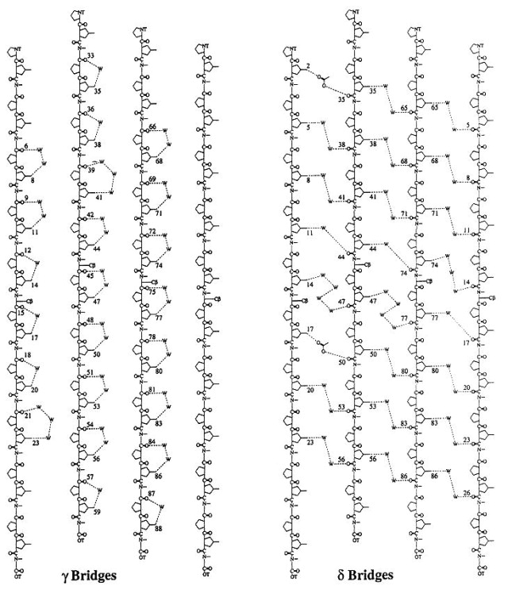

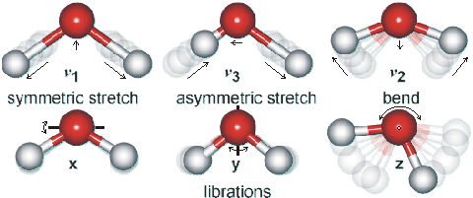
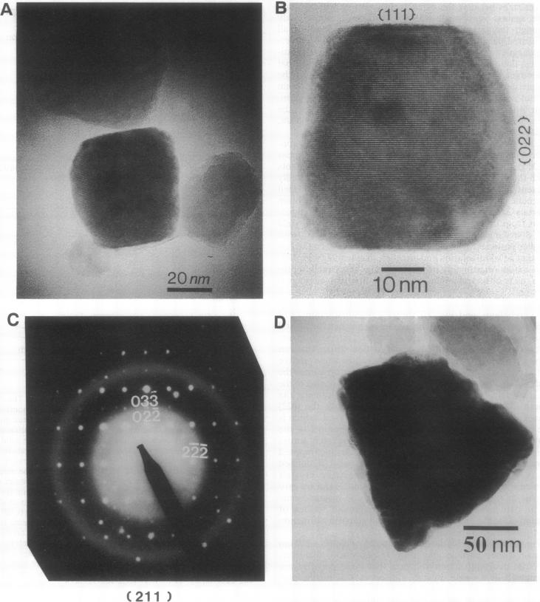
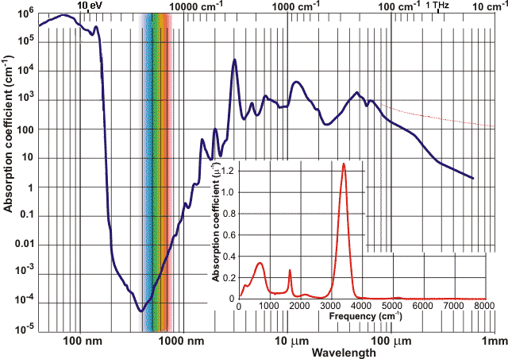

LINKS
http://onlinelibrary.wiley.com/doi/10.1002/ar.10185/full
http://journal.frontiersin.org/article/10.3389/fnint.2014.00084/full
http://www.affs.org/html/biomagnetism.html
http://www.i-sis.org.uk/QuantumCoherentOrganism.php
http://www.ncbi.nlm.nih.gov/pmc/articles/PMC49775/
http://www1.lsbu.ac.uk/water/magnetic_electric_effects.html
https://en.wikipedia.org/wiki/Electromagnetic_absorption_by_water
http://www.chinahealthways.com/researchemitedchi.htm
http://www1.lsbu.ac.uk/water/water_vibrational_spectrum.html
http://www.i-sis.org.uk/Collagenwaterstructurerevealed.php
http://www.ncbi.nlm.nih.gov/pmc/articles/PMC49775/pdf/pnas01090-0405.pdf
http://downloads.hindawi.com/journals/ecam/2011/260510.pdf
http://www.ncbi.nlm.nih.gov/pmc/articles/PMC4224074/
http://www.measurement.sk/2005/S2/Lipkova.pdf
https://www.researchgate.net/publication/228571232_Calculation_of_the_electromagnetic_field_around_microtubule
https://www.researchgate.net/publication/235368209_Vibrations_in_Microtubules
http://www.ncbi.nlm.nih.gov/pubmed/12467083
http://www.i-sis.org.uk/lcm.php
http://www.i-sis.org.uk/QuantumCoherentOrganism.php

